Proving the
Wrongful Conviction
of Nicole Kish

In this essay I make the case that Nicole “Nyki” Kish, has been wrongly convicted of murder in a judge only trial. Arrested on the night of her 21st birthday, she has already lost almost the entire first decade of her adult life. After placing the body of this article in context, I will offer proof, including illustrative photographs, that the central conclusion of fact made by the judge is completely wrong, and that the evidence actually supports the defense.
On August 9, 2007 Ross Hammond was fatally wounded in a street altercation in Toronto. He and his friend, George Dranichak, had been asked for money by a young woman. Their response, suggesting that the woman earn the money by performing a sexual act, started a brawl with a number of “street kids” that ended in Hammond’s death from a knife wound to the heart. Hammond was dragged up the street while attempting to enter a passing cab. He collapsed by the steps of a church still in possession of the knife he had used to stab Nyki in the arm. The Crown would offer an unlikely theory that Nyki had first stabbed Hammond with that knife, only to have him grab it and stab her.
Nyki was charged and convicted of second degree murder, despite the fact that not a single witness saw Hammond being stabbed, much less identified Nyki as the one who stabbed him. Toronto had had a problem for years with aggressive panhandling. The media went into an all too familiar feeding frenzy demanding that the police make an arrest.
True to form, on the very day of Hammond’s funeral , Detective Sgt. Gary Giroux announced that Nyki would be charged with the murder of Ross Hammond. He made this announcement at an actual press conference. Those who have studied wrongful convictions know that once the police have decided who to charge, they no longer investigate in search of the truth. Rather they seek proof of what they think they already know. To announce their conclusion at a press conference locked them in a hundred times over.
The real reason Nyki was charged was simple. She and three friends were the only ones arrested at the scene. They had stayed only to seek medical help for Nyki. Indeed, she wanted to go in the same ambulance as Hammond. Not something she’d likely have done if she’d stabbed him. However the three friends were all Americans. Her boyfriend at the time, Jeremy Wooley, and two friends, Faith Watts and Douglas Fresh, would all be sent back to the US. Meanwhile a media driven agenda was forming to make an example of a panhandler. It had to be a Canadian to serve this purpose. It may well have been an additional factor that railroading an American would have involved the American media.
Because of the negative pre-trial publicity, in which Nyki was actually dubbed the “Panhandler Killer”, the decision was made by the defense to have a judge only trial. The defense mistakenly believed that a judge would fairly consider the lack of physical evidence and witness confirmation to conclude that the Crown could not meet the burden of proof. Instead Justice Ian Nordheimer took it upon himself to construct a theory of what happened by cherry picking not just which witnesses to accept or reject, but which pieces of the same witness’ testimony to include or not.
As proof that this was done in support of a pre-existing agenda, I cite one feature of the judge’s verdict. He explicitly concludes that Nyki was the panhandler who started the incident. In doing this, he contradicts both the Crown’s own narrative, and the testimony of the only witness. That witness was George Dranichak, the man from whom money was actually asked. Neither identifies Nyki as the panhandler. It must be remembered that there is nothing about the charges brought against Nyki, neither in law nor logic that would require her to have been the one who asked for money. This wholly gratuitous assertion is needed only to serve the agenda of making an example of a panhandler. Thus Nyki must be the panhandler, regardless of the truth, just as she must be the murderer, again regardless of the truth.
In his verdict, Justice Nordheimer constructs an elaborate scenario in which a chaotic street brawl is reduced to only seven participants, despite numerous witness reports of others being involved. He also divides the fight into two segments, one on the south side of the street near a stopped street car, and a continuation on the north side during which Hammond was stabbed.
All parties agree that at one point Hammond was severely beating Douglas Fresh on the south side of the street. This was observed by two witnesses looking out of the south side of the aforementioned street car that had stopped at this corner. They report that a woman inflicted several relatively minor knife wounds to Hammond’s back to make him stop his attack on Fresh. Hammond then broke off to run to the north side of the street. Faith Watts testified from the US via video link for the preliminary hearing that it was then that Hammond took her knife away from her. The judge accepts that the Crown’s alleged murder weapon was Watts’ knife, but simply chooses not to believe the rest of her account.
By concluding that since there is only one knife known to be in play, it must therefore be the only one in involved, Justice Nordheimer reaches unwarranted conclusions. Two witnesses testify that they saw a woman who “might” have been Nyki jabbing Hammond on the south side of the bus to save Fresh. They further testify that they think she “might” have been the same woman who was cut on the north side. Neither was certain, one even admitting that she might have interchanged Nyki and Watts or even someone else. Neither of these witnesses ever picked Nyki out of a photo lineup. Indeed, no witness ever picked her out of a photo lineup. The only witness to identify anyone from photos got it wrong, interchanging Nyki and Watts.
Justice Nordheimer accepted these vague and uncertain “identifications” as proving that it must have been Nyki who was jabbing Hammond. This despite the fact that he accepts that the knife belonged to Watts and that Fresh was her boyfriend, not Nyki’s. At this point he ignores the fact that Hammond’s DNA was found in multiple places on Watts’ clothing, while repeated tests of Nyki’s attire ultimately found only a small bit of DNA on the tip of one of her shoes. As Hammond’s blood was found in multiple locations on the street, it is easy to realize that at some point she must have stepped on it. Experts agree that knife fights always involve the transfer of DNA between the participants.
Furthermore, by choosing to reject Watts’ testimony that Hammond took the knife from her, and since all sides accept that Watts stayed on the south side, Justice Nordheimer concludes that Nyki must be the one who transported the knife to the north side where she fatally stabbed Hammond. It was then that Hammond seized the knife from Nyki and severely cut her arm.
Only be saying that the knife recovered from Hammond is the one that wounded him, and that it is the same knife that cut Nyki, is his verdict sustainable. Justice Nordheimer relies on the presence of Hammond’s blood on the blade, near the hinge, as proof that this is the knife that killed him. Nyki’s blood also at the hinge is his proof that this is the knife used to wound her. If it is not the knife that stabbed them both, his entire verdict falls apart.
By his own rulings, Justice Nordheimer should never have reached this conclusion. During the trial, he rules that he must rely on the only forensic expert witness available, Dr Michael Pollanen who testified for the Crown and not theorize on his own. Yet in his verdict, the judge ignores the fact that Dr Pollanen refused to say whether the knife presented by the Crown was or was not the murder weapon. The limits of forensic science simply do not allow such a conclusion. Instead the judge plugs this hole in the Crown’s case with what I believe is an erroneous conclusion of his own.
What proof is there that the knife presented as the alleged murder weapon is actually the knife used to mortally wound Ross Hammond? All we are offered in Justice Nordheimer’s verdict is his unsupported conclusion regarding the blood found on the hinge, from which he launches an entire web of backwards reasoning. I believe that there are powerful reasons to reject the Crown’s theory as unlikely or even impossible. I also believe that a more viable theory exists along with compelling evidence that it is what actually happened.
First there is the issue of physically matching the knife to Hammond’s wounds. The Crown’s expert witness, Dr. Pollanen of CFS (Canadian Forensic Service) declined to offer a definite answer as to whether or not the knife presented at trial was the one used on Hammond. From my readings in a number of forensic science textbooks, I have found that it is virtually impossible to make a definitive finding barring very special circumstances.
From Forensic Pathology, Second Edition by Dominick DiMaio, Vincent J.M. DiMaio, M.D.
“…Was the blade serrated? Was more than one knife used?
One should be extremely cautious in giving answers to these questions. In most cases, on examining a wound, the most information that can be deduced is the maximum width of the blade, an approximation of the length of the blade, and whether it is single-edged. If the stab wound passes at an oblique or perpendicular angle to Langer’s lines, one must reorient the wound edges to see the true appearance of the blade.
In most instances, the most that one can do when presented with a knife and asked if it was the weapon that produced a specific wound is state that it could have been. To be sure that a knife blade was serrated from the appearance of the wound is rare.”
From: http://www.pathologyoutlines.com/topic/forensicsbluntforce.html
● The guard of the knife may produce a patterned abrasion if it is stabbed with significant force into the skin; this can aid in identifying the weapon
● If the weapon comes into contact with bone, the tip may break off and remain in the body; this can be used to identify the weapon
From the above text we note that these conditions consist of either having some portion of the blade brake off inside the body and thus be available for comparison to the rest of the blade, or if it leaves some special mark or the skin, or the wound may be absolutely too deep for the blade to have made it thus ruling out that particular knife. The latter is somewhat subjective when the distance is close to the blade length due to the compression of tissue that occurs under a heavy blow. The presence of distinctive markings about the wound, such as from the guard or a thumb stud might provide strong indicators but not necessarily proof. A serrated blade can also leave detectable markings, or it may not.
Bear in mind that this indicates that the Crown always knew that Dr. Pollanen could explain the cause of Hammond’s death, but NOT establish the knife in question as the murder weapon. They always knew that they were proceeding without this confirmation in addition to having no witnesses to the crime itself.
Second, there is a shocking gap in the evidence collected by the police while swabbing the alleged murder weapon for DNA. As indicated on the photos of the actual knife below, swabs were taken only of the hinge, the handle and the pommel of the knife. NO swabs were taken from the functional portion of the blade, its cutting edge, sides or point.
Photo A is of the blood stained knife stub side with arrows indicating swab and non-swabbed sites

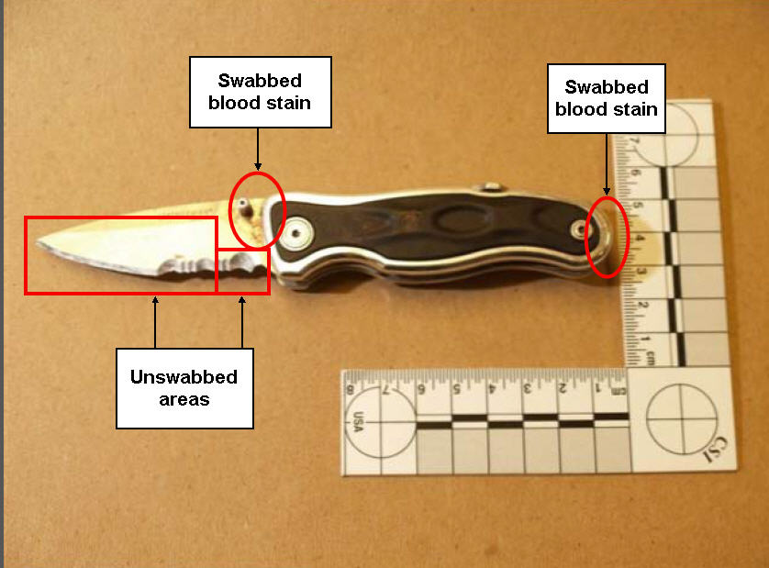

Photo B is of the blood stained knife clip side with arrows indicating swab sites and an non-swabbed possible blood stain.
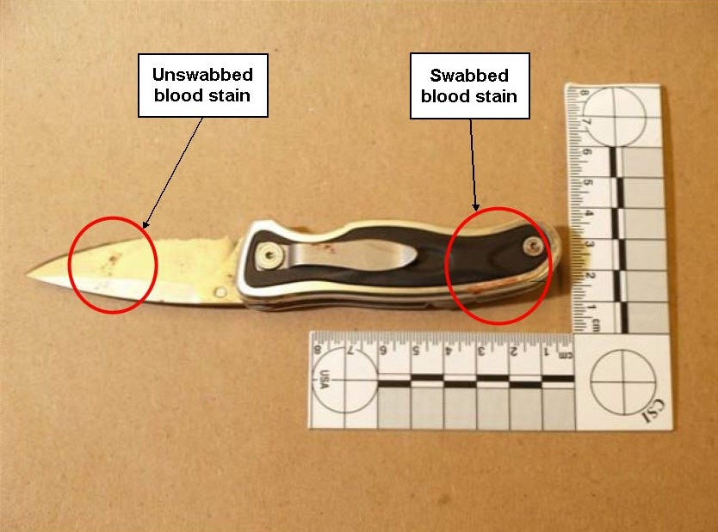
Dr. Michael Spence of Spence Forensics was kind enough to inform me that as few as 400 nucleated cells would be sufficient to identify the blood donor. By failing to swab this area, the authorities passed up the chance to prove that Hammond’s blood was on the blade itself, and not just on the hinge area. Perhaps it was only Nyki’s blood, and that would have been an embarrassing result for them and a useful one for bolstering the defense.
Some of my readings on this subject indicate that this pattern of swabbing a knife might derive from having a prime focus on the handle in order to determine who wielded the knife rather than who was injured by it. While this is the most common situation, it is not applicable in this case, since the question of who was stabbed with this knife is as much at issue as identity of the one who wielded it. Note that Hammond, apart from saying “no comment” in regards to the knife, said that he had taken it from “his” hand in reference to a street kid, but NEVER said that he himself had been stabbed with it.
OTOH, the following items from the CFS listing of samples for testing show that the Leatherman multi-tool belonging to Doug Kruz aka Fresh WAS swabbed at its cutting edges and tested for blood even though it was never seriously suspected to have been used to injure anyone. It thus seems inexcusable that this was not done with the alleged murder weapon itself, whatever the reason may have been.
From the CFS report:
“2. Blood was not detected, using the Kastle-Meyer test, on the following items:
From: Douglas Kruz
Item 18 Swab of cutting edges of multi-tool
Item 19 Swab of cutting edge of serrated blade of multi-tool”
Was this a deliberate omission? Was a swab taken that was then lost, just as crucial video evidence was also lost? Given the many irregularities of this case, one has to wonder whether this is yet another instance of suspiciously missing evidence. Nor can the authorities fall back on the defense that when the swabs were taken this was not yet a murder case. The cyano-acrylate fuming technique to bring out latent fingerprints does NOT preclude the collection of additional DNA samples, so they did have the opportunity to go back and do it right at a later time.
No doubt some readers are familiar with Greg Hampikian, Ph.D. from his wonderful support of Amanda Knox and Raffaele Sollecito in the Italian travesty of the Meredith Kercher murder case. Here is his response to my query on this issue:
“Cyano-acrylate will not prevent further DNA testing. Often they go for DNA testing in spots with visible blood or gunk (where material drips or slides).”
There is a definite large spot on the clip side of the blade. Is it Nyki’s blood, or Hammond’s, or both, or is it even blood at all? We’ll never know, because they didn’t test it. In a case where evidence not collected or preserved was not available to be used in Nyki’s favor, it would be utterly beyond the pale for the courts of any civilized nation to allow the hypothetical results of tests not done at all to be assumed to be inimical to the defense. We are left to follow the authorities’ lead, and dismiss the spot from consideration, noting only that this matter is further proof of the utter lack of rigor in this investigation.
In any case, had they tested it and found only Nyki’s DNA, that would have bolstered her defense. Had it been a mix of her DNA and Hammond’s, that would not have proved that he was stabbed in the chest with this knife. Give the spot’s position relatively low on the blade, it would at best be a possible indicator that this knife was indeed used by Faith Watts to jab Hammond’s back to rescue Doug Fresh.
Photo C is an enlargement of the possible blood stain from the clip side of the blade which wasn’t swabbed.
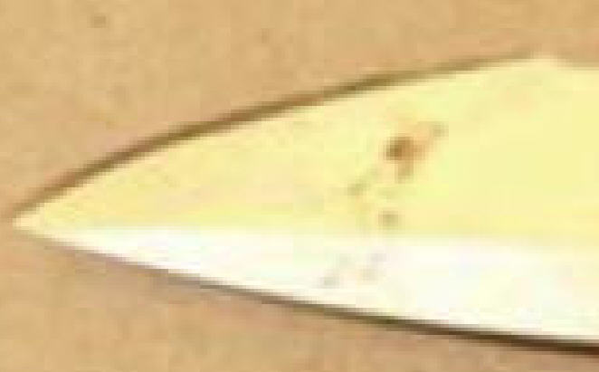
Now we come to the “irresistible inference” from Justice Nordheimer’s verdict.
From Justice Nordheimer’s verdict:
“In addition to those considerations is the fact that the blood of Ross Hammond and of Nyki were found mixed together at the hinge of the knife, that is, where the blade meets the handle. It is again an irresistible inference from that fact that the same knife caused the wounds to both.”
From Clive Wismayer brilliant analysis of the verdict:
“With respect, it is no such thing. Hammond could have been stabbed by another knife altogether but got his blood on the one he wrenched away, either in the course of doing so or simply by holding it with his injured and bloodied hands. There was no expert’s
evidence before the judge to the effect that blood at the hinge signified anything and it is
not clear whether his reference to this is merely descriptive or actually a stepping stone in his reasoning. If the latter, there is no evidential basis for it and it is not explained.”

As Clive has pointed, there is NO expert testimony on how to interpret the blood at the hinge. It has been pointed out by the defense that Hammond’s hands were cut and bleeding, and that this could be the source of his blood instead of having come from stab wounds. But while these secondary injuries might seem to be a possible source, the specific nature of his wounds and of the way in which the knife was constructed powerfully suggests a compelling alternative explanation for finding his blood on the hinge.

The photos below were made using a Leatherman e305x knife. While the e305x is a discontinued model, I was able to obtain one on eBay. This is the exact make and model of the knife recovered from the location where Ross Hammond collapsed, and is a perfect twin of the knife which the Crown presents as the alleged murder weapon.
Photo 1, the Leatherman e305x with its blade fully extended.
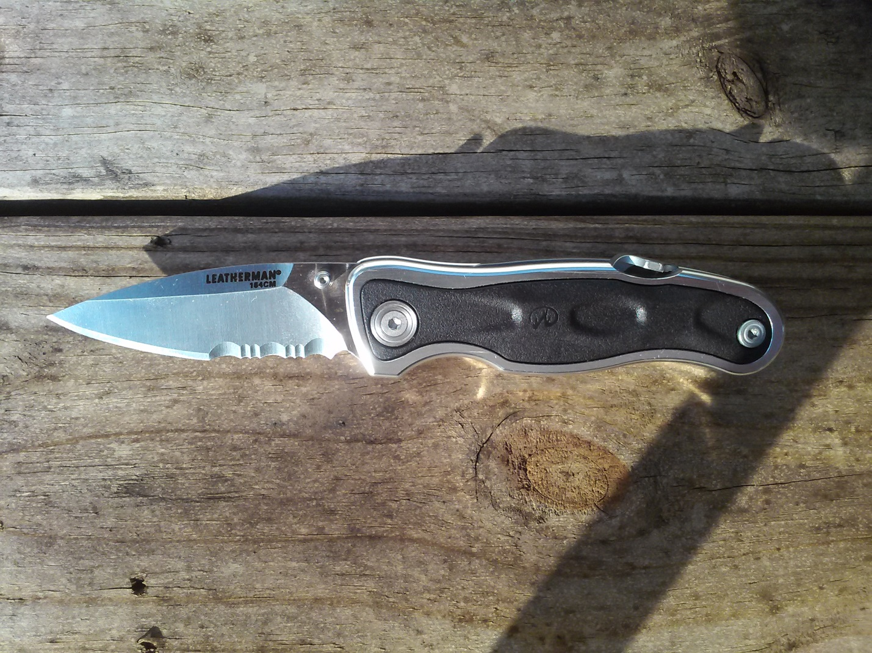

And photo 2 with the blade fully closed.
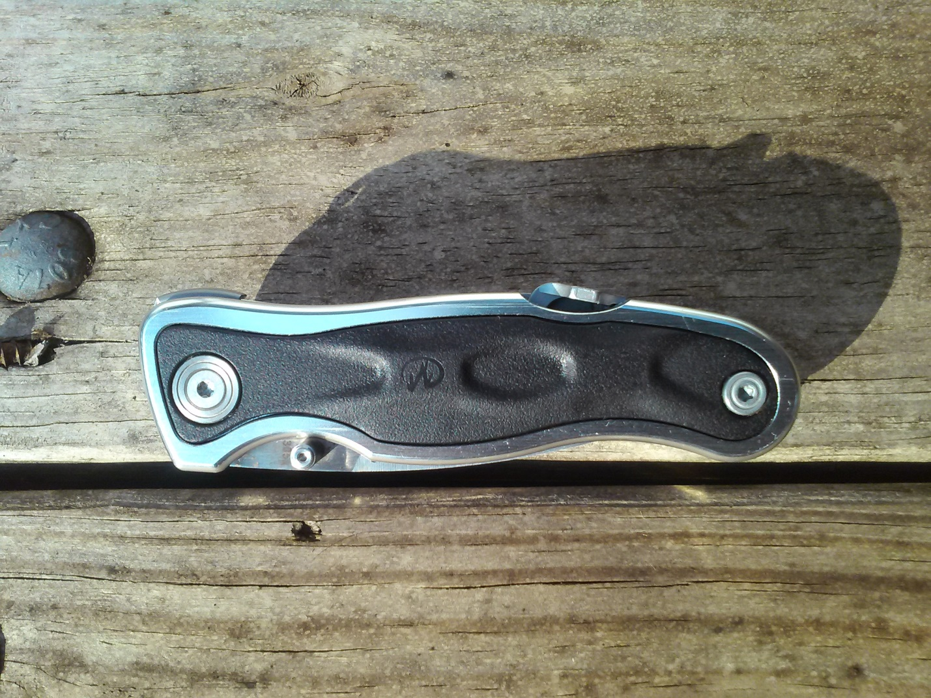
The e305x is a folding pocket knife that utilizes the popular “liner lock” mechanism to keep the blade locked in the open position when deployed. This is the metal bar shown leaning towards the upper right of the area into which the blade is folded as shown in photo 3.
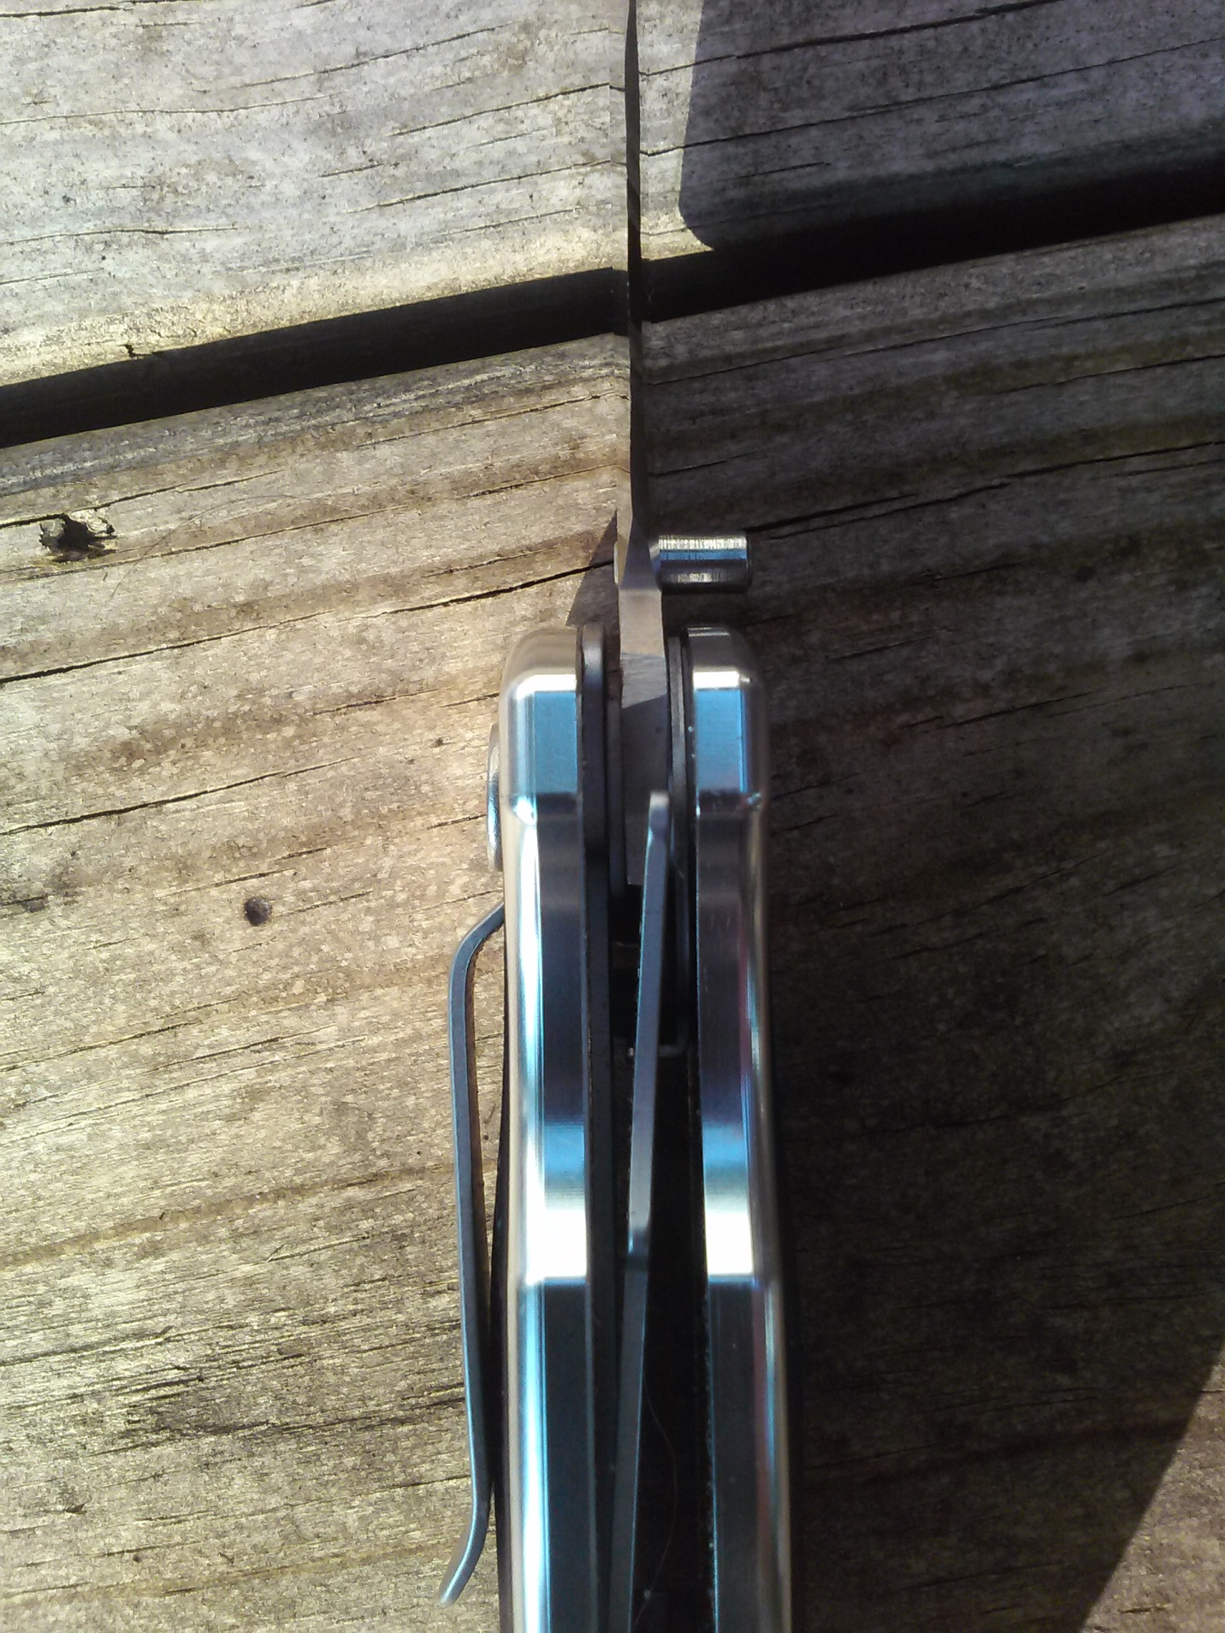
The critical point is that to close this type of knife, you would put the tip of your thumb across the opening that houses the blade in its closed position to push a steel band all the way against the outer wall of the handle. You must then partially close the blade before releasing the thumb pressure or else the blade will relock.
From http://www.dougritter.com/pop_up_axis_lock.htm : “With a traditional liner lock, it is virtually impossible not to place the thumb across that opening to release the lock, the exception being some few knives with alternate operating mechanisms that haven't really caught on for a variety of reasons. I know many who have seriously cut themselves while closing these knives. Not as many as have cut themselves with non-locking knives, but it is a definite risk.”
Photo 4 is the thumb’s starting position.

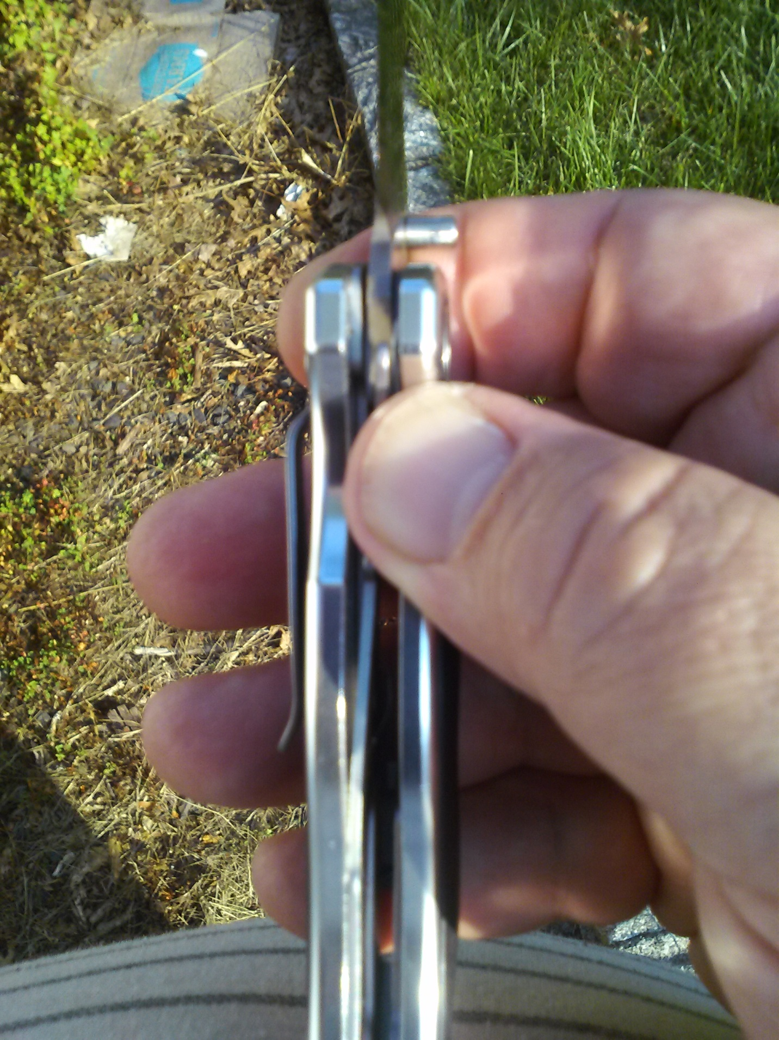
Photo 5 shows the thumb pushing the liner lock all the way to the left.
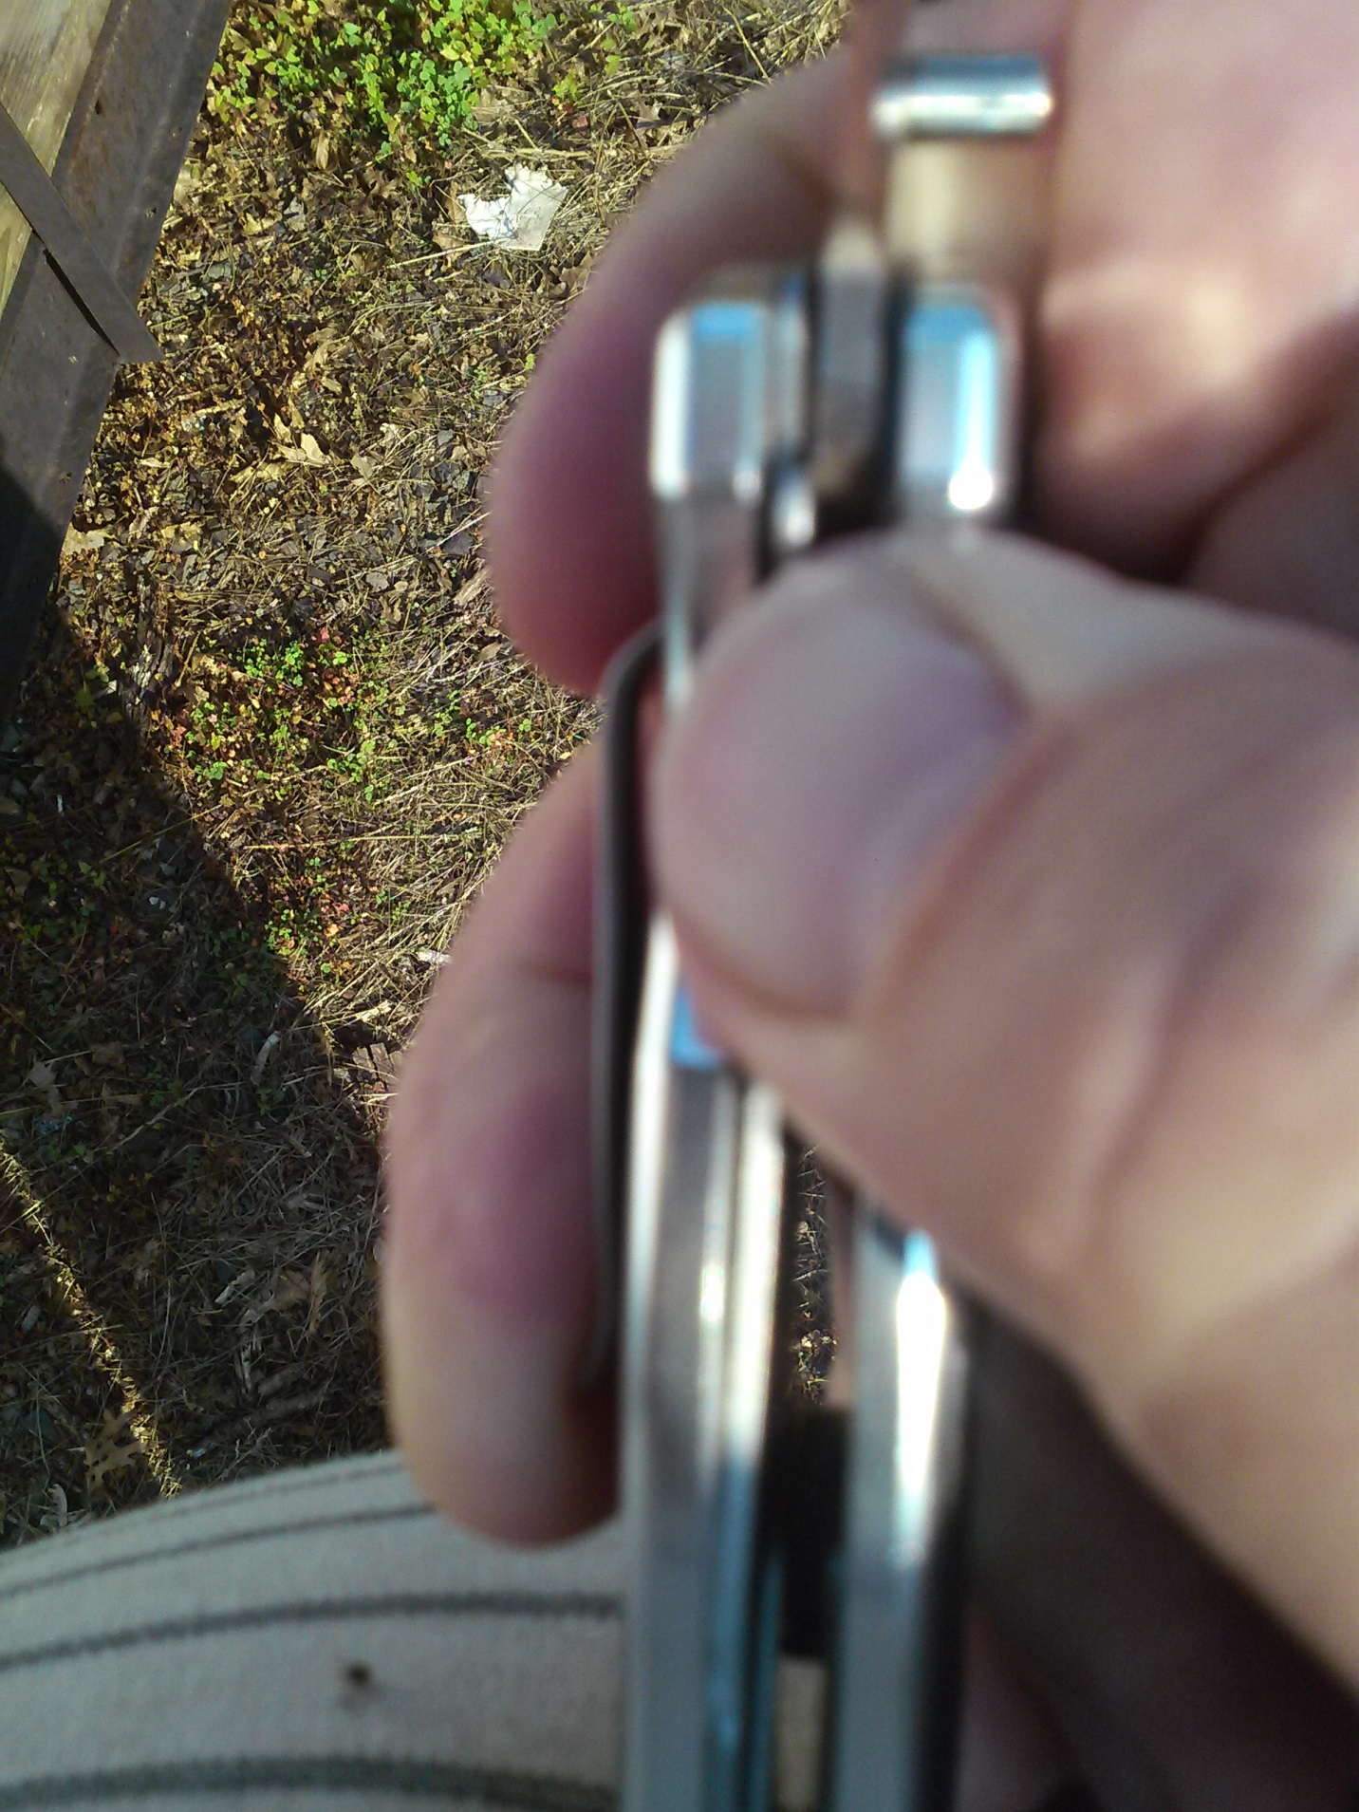
With the metal bar now in the unlocked position as shown in photo 6, the index finger is hooked around the dull edge of the blade to close it.
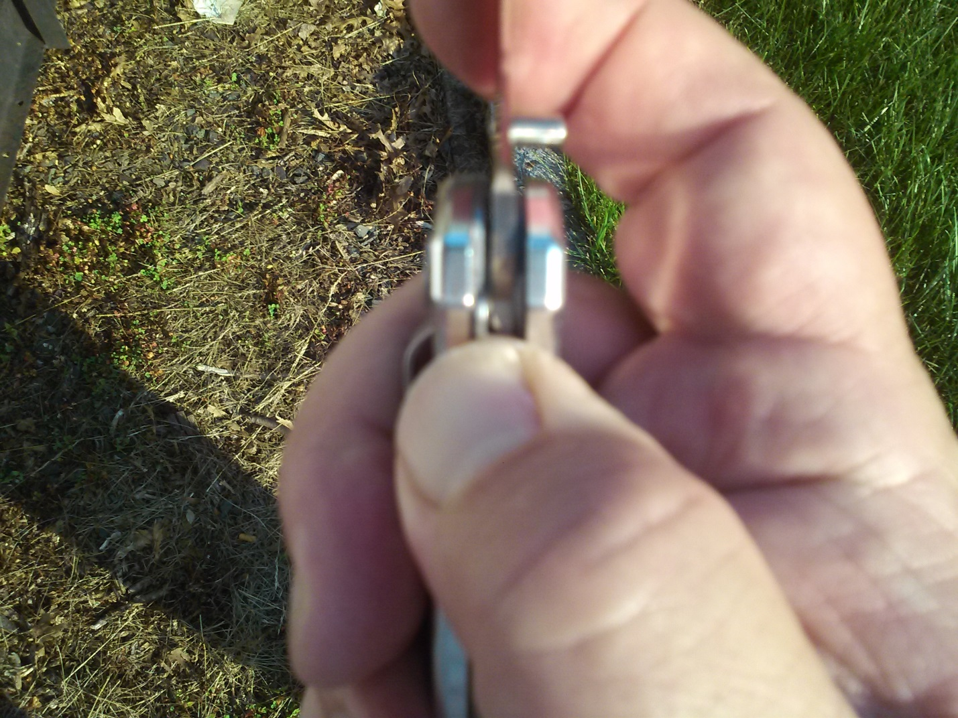

Photo 7 shows the positions of the thumb and the blade if the thumb is not moved safely out of the way.
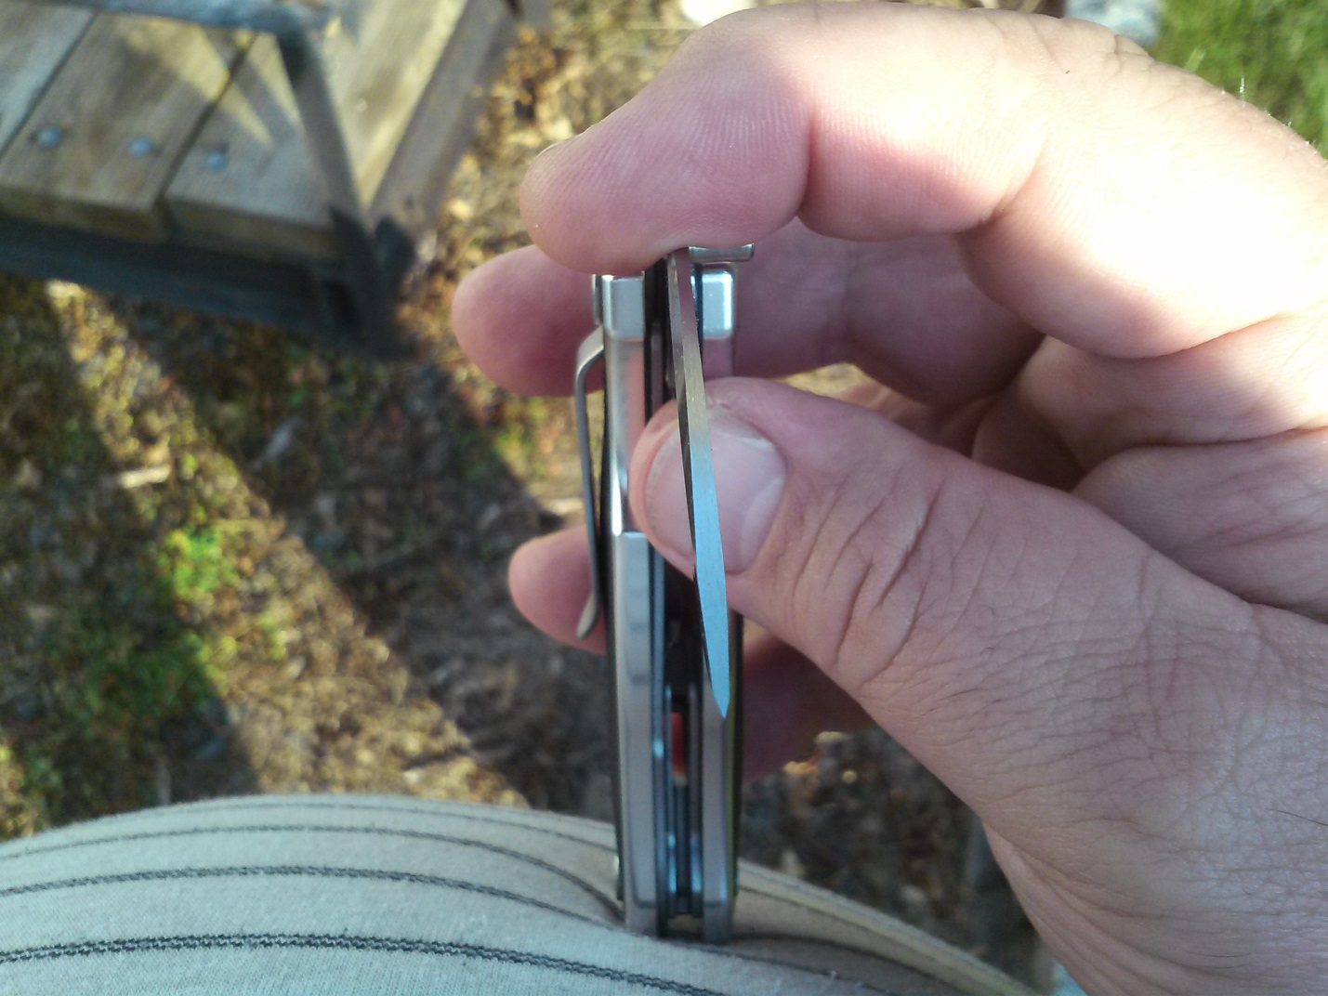

Contact is made between the blade and the thumb in photo 8.
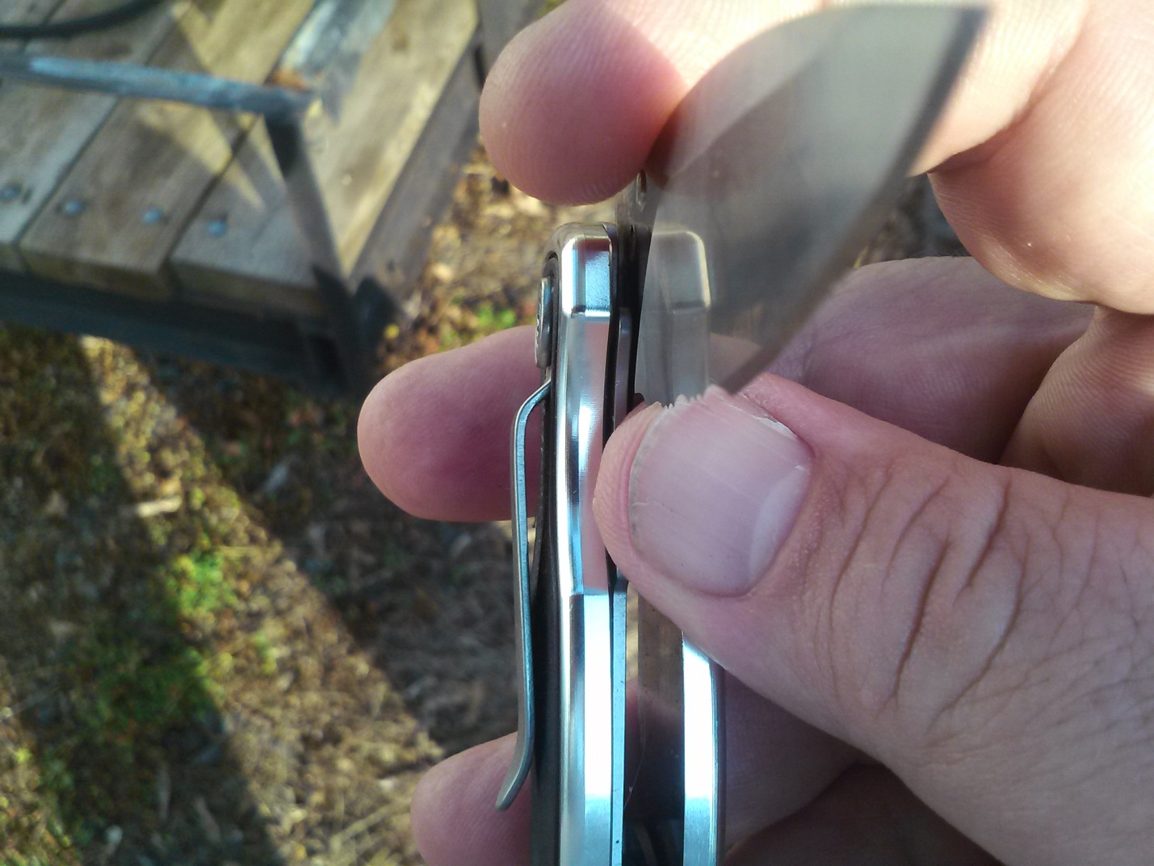
It is absolutely vital that you move your thumb out of the way before closing the knife completely! If you failed to move your thumb entirely out of the way, you would slice off the tip. Most likely it would be just the skin, not all of the way to the bone. The cut would also tend to be at somewhat of angle such that it would remove more skin on outer side of the thumb than the inner, as you can verify looking the position of the thumb in the photos.
This is EXACTLY the wound that Ross Hammond sustained to his right thumb. I think it likely that he took the knife from Faith Watts just as she testified. As he then headed across the street, he slammed the knife closed and put it in his pocket. Drunk, angry and full of adrenaline, I doubt he even noticed what he’d done to himself. It seems to me too great a coincidence for this to have been a “defensive” wound as the Crown would have us believe. What happened to Hammond is just too perfect a match to the type of injury I’ve described. But we need not rely upon my description when we a have an official drawing from Dr. Pollanen’s post mortem report as shown in Photo D.

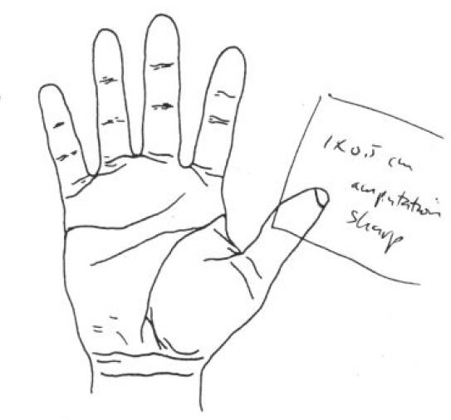
Compare the thumb photos to this drawing of Hammond’s right hand made by Dr. Pollanen. They clearly show the line of the cut slanted in EXACTLY the type of angle as in the drawing above. Less tissue was lost from the side of the thumb nearest the index finger, and more was lost from the outer side of the thumb.
In his testimony, Dr Pollanen admitted that he never examined the knife itself. Instead he only viewed photos of it.

Q. …. And --did you actually examine this knife?
A. No.
Q. You just looked at pictures?
A. Right.

Had he bothered to examine it, and most particularly if he had ever tried to close it, I believe that there is a very good chance that he too would have noticed the exact correlation of the position of the thumb when operating the mechanism with the partial amputation of Hammond’s thumb. This is just one more example of the shoddy manner in which the forensic evidence was handled in this case.
I believe that after closing the knife in this manner, Hammond then placed it in his right rear pocket, as attested to by his own blood stains both on and in that pocket. This would have allowed him to run through the pasta video without the knife being visible. During the video, he seems to me to quite deliberately stop and turn about to run back in much the same direction from which he came. I think that as he left the camera’s field of view, he took the knife back out. Possibly he may have been going back to help his friend Dranichak.
It is also possible that he did have the knife in his hand as ran through the view of the pasta video, and that we cannot see it due to the very poor resolution of the video. If he was carrying the knife in his hand, all of the handle would have been concealed by the way it would have been in his grip. Only the blade would be visible. Think how thin a knife blade is when viewed edge on, rather than looking at the sides of the blade. Judge for yourself whether a knife would be visible in this frame, and whether we can conclude from this image that Hammond did not have possession of the knife at this time.
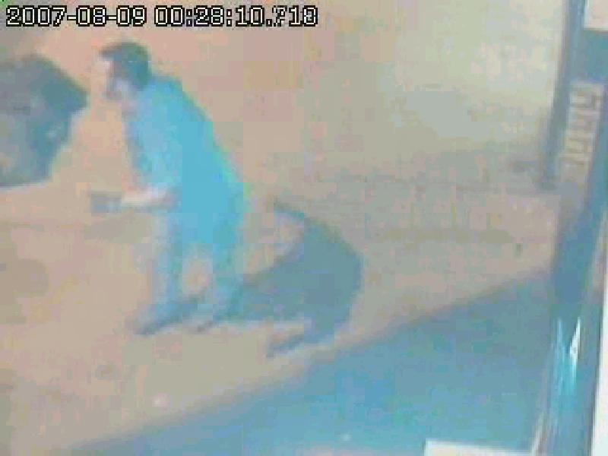
The resolution of this video is so poor that there are times when entire limbs seem to disappear from the people who walk through it. Note the woman in this next frame who is NOT really missing an arm. This is simply an artifact of the compression that occurs in making such a low resolution image. Even so, the fact that a knife was not observable in Hammond’s hand in this video was construed as a proof that he was not carrying the knife at this point in time.
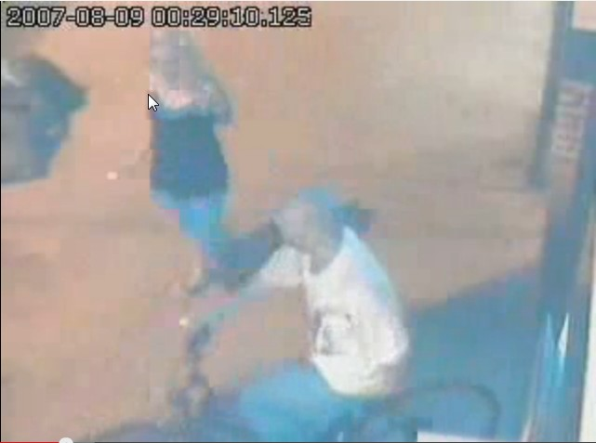

Unless the side of the blade faced the camera, and probably unless it actually reflected light directly into the lens, it would not have been visible. Either way, the partial amputation of his thumb indicates that he closed the knife at some point and then reopened it later.
But in reopening the knife, a SECOND transfer of his blood onto the hinge would have occurred. Photo 9 shows the knife as it would be held when it is to be opened.
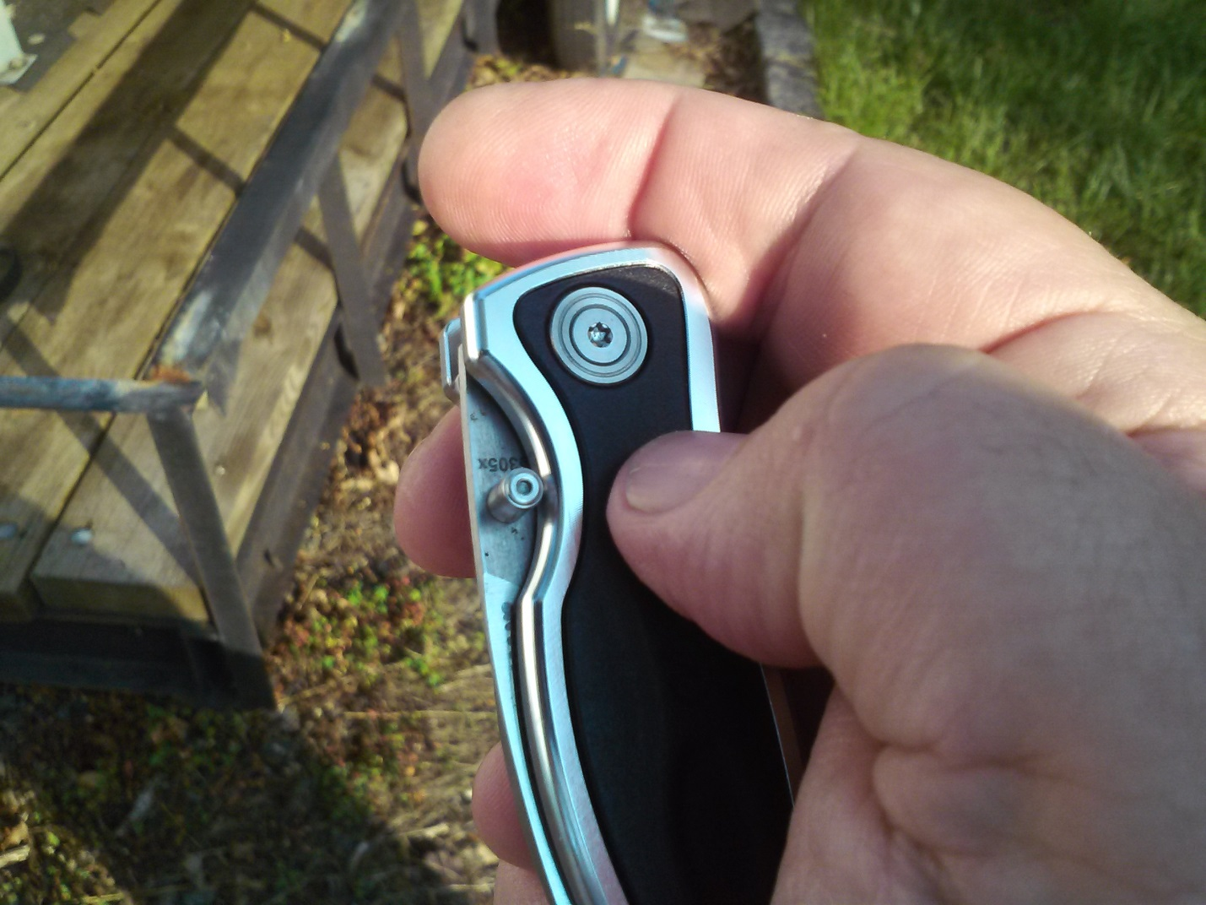

Photo #10 shows how the thumb is used to push the thumb stud. But this is once again EXACTLY the part of Hammond thumb that had been cut off.
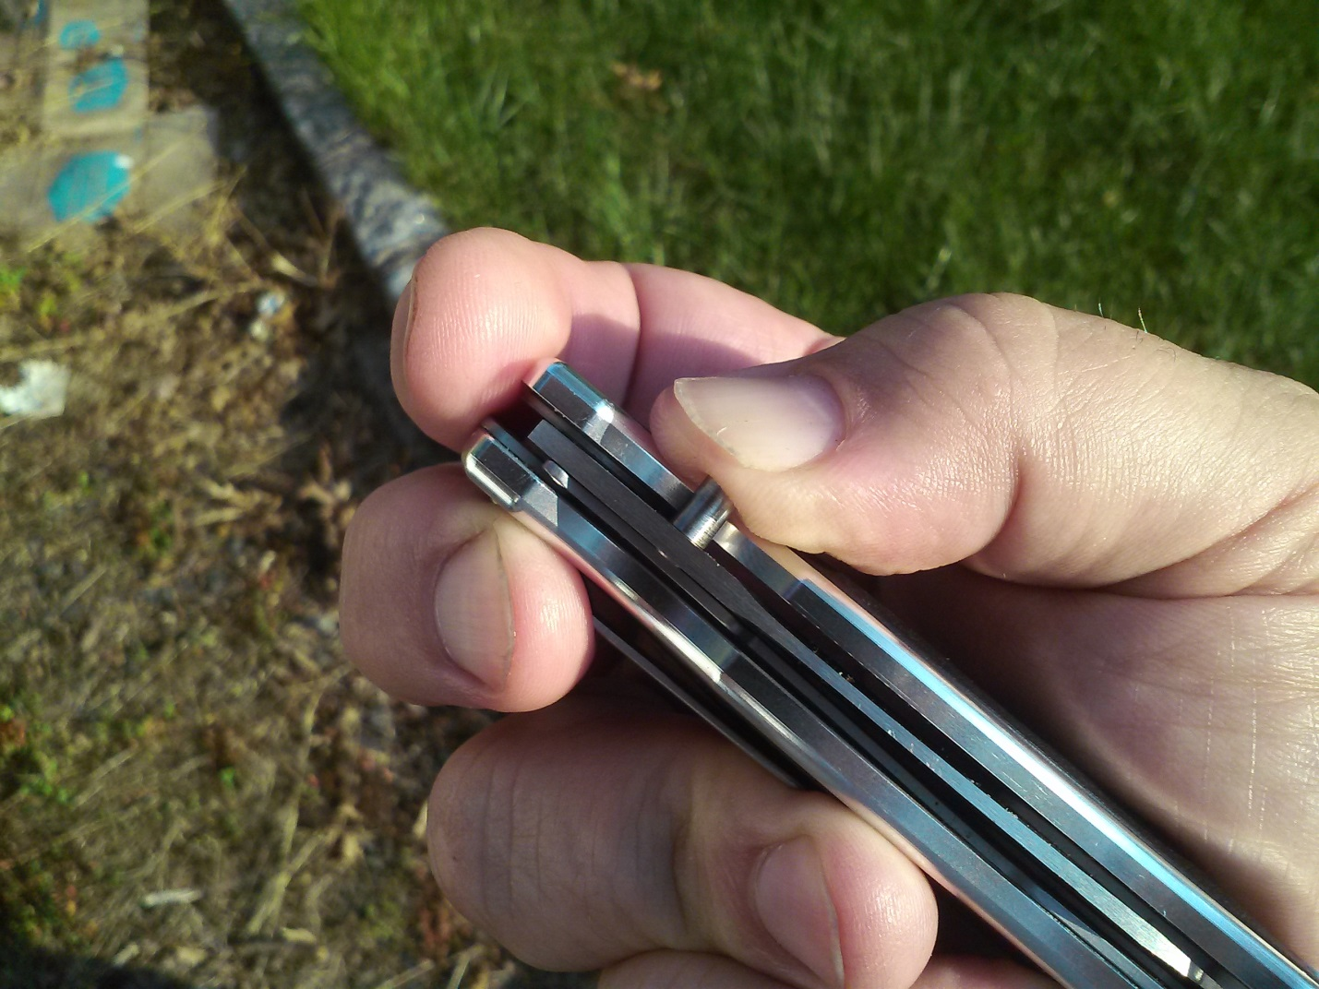

Photo 11 shows how the continued motion of the thumb pushing out the blade exposes the hinge area which slides out in direct contact with this open wound.
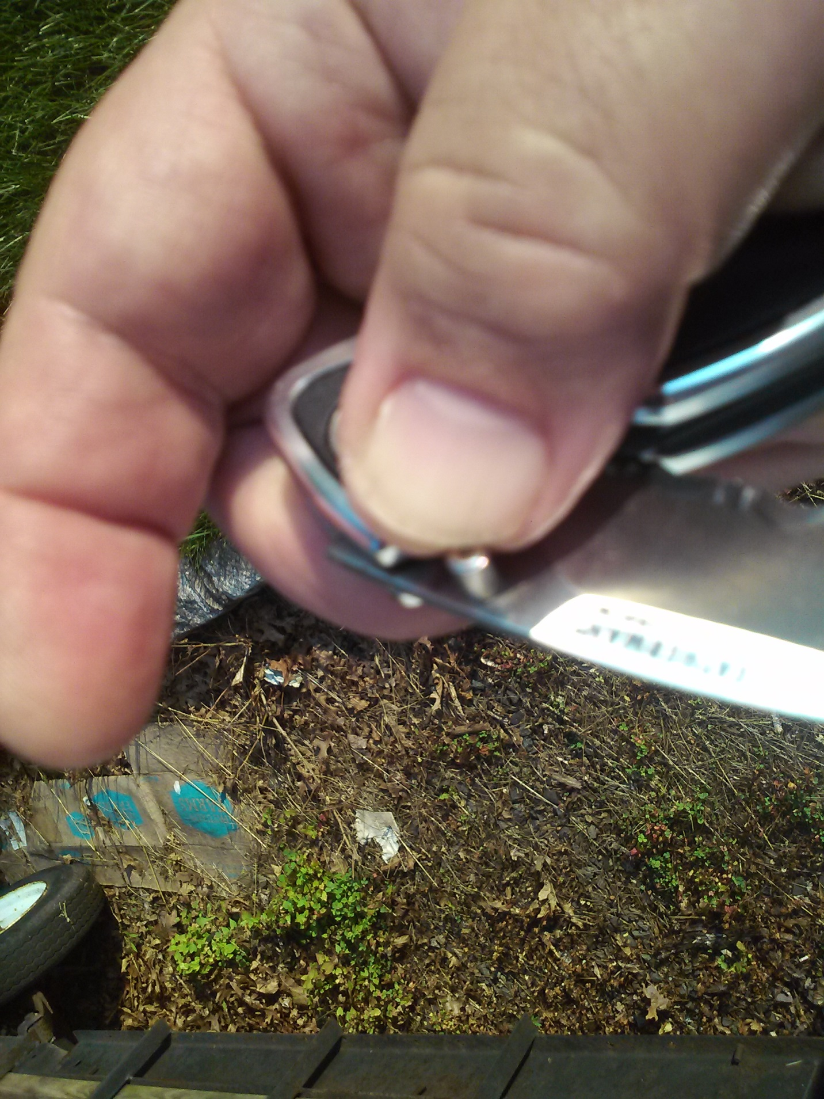

Are there indications that it actually did happen this way? I believe there are two. First, if the theory above is true, we would expect to find more blood on the stud side of the hinge than the clip side. In cutting off the tip of his thumb, the rest of Hammond’s finger on the stud side would have been a far richer source of blood than the small, amputated piece of skin that quickly fell off. This would have been augmented by the second transfer of blood that occurred when he operated the thumb stud to open the knife, and which would only have placed blood on the stud side. Viewing the stub and clip sides of the alleged murder weapon side by side in Photo E, we see that this is EXACTLY what has occurred.
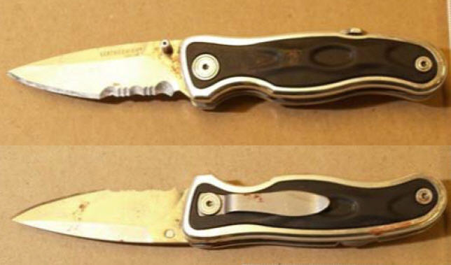
The second reason is the question of how Hammond’s blood could have gotten above the stud without the stud having left a mark of its own on his wounds. Photo F shows the size and prominence of the stud.

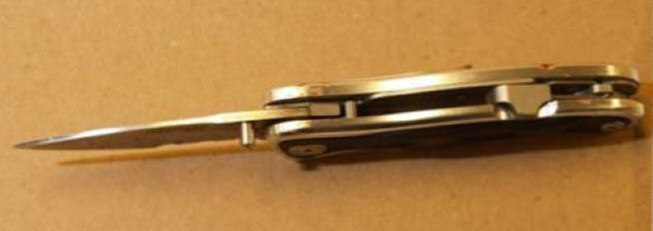
The amputated thumb seems a much better explanation for Hammond’s blood being on the hinge than his having been stabbed with that knife. In any case, if this possibility is at all viable, it constitutes reasonable doubt that this knife is the murder weapon and Nyki should never have been convicted.
Should we expect to find Nyki’s blood on the clip side of the hinge? Not necessarily, as there are several ways in which the blood from Nyki might also show a pronounced bias as to one side of the hinge having a greater amount. We do not know the precise angle at which the blade penetrated Nyki’s arm. It may have greatly favored the stud side.
Nor can we judge whether the stud should have left a mark. Unlike Hammond’s wounds to a very solid area of this chest wall, Nyki’s wound was inflicted on the soft tissue of her upper forearm. The stud might have impacted her skin, but would have been less likely to leave a mark. Nor was her wound subject to forensic examination, just an emergency procedure to stop the blood flow and suture. This was followed a few days later by further surgery to mitigate the chance of permanent nerve damage. So perhaps it did leave a mark which has simply not recorded because no one looked for it.
Again from Forensic Pathology, Second Edition by Dominick DiMaio, Vincent J.M. DiMaio, M.D.
“All knives thought to have injured or killed an individual should be examined for the presence of blood or tissue. Any blood or tissue present can be typed by DNA techniques so as to link the weapon to the victim. It is possible for a knife or similar weapon to not show microscopic blood staining after it has been used to stab an individual. In stab wounds of solid organs, bleeding occurs only after the knife is withdrawn because pressure of the knife in situ prevents bleeding. During withdrawal of the knife, the muscular and elastic tissue of the solid organs stabbed or the elastic tissue of the skin may contract about the knife and wipe off the blood present on the blade of the knife. During its withdrawal from the body, the knife may also be wiped clean by the clothing. If a knife appears to be free of blood, the handles should be removed to see if any blood is there. With folding knives, the recess for the blade should also be tested for blood. Even though the blade or recess may appear to be free of blood or tissue, analysis of wipings of the blade might still yield sufficient tissue to perform at least limited DNA analysis and typing. This may be sufficient to link a weapon to a victim.”
Given the information above regarding the tendency for blood to be wiped off the blade by surrounding tissue, it may be that Nyki’s blood was only retained on the area of the stain at the stub because it was captured by Hammond’s dried blood already present from his previous actions. Note the apparent position of what seems likely to be the swabbed area in photo G.
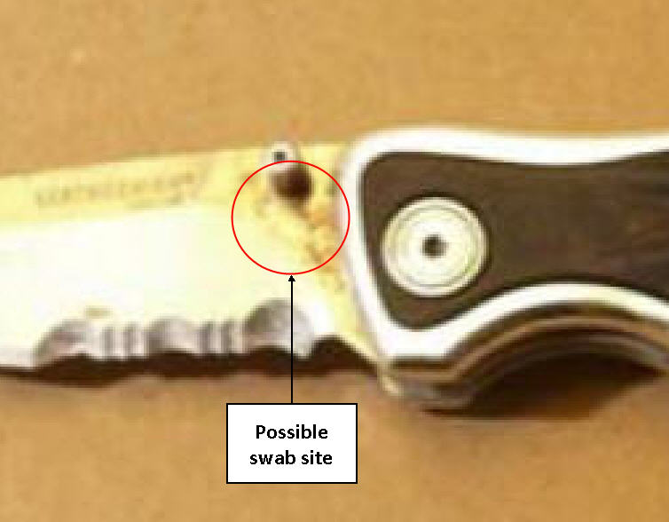
Finding Hammond’s blood in quantity on only the stub side of the hinge rather than both sides, and above the thumb stud, seems to me a physical impossibility to have gotten there by his having been stabbed with this blade. It must also be asked how the blood stain could be found above the stud without that stud having left a noticeable mark on his wounds. Even without the alternative explanation presented in this article, Justice Nordheimer ignores these problems with his conclusion. But note that both he and the Crown seem to be implicitly accepting that the blood on the two swabbed areas on the handle of the knife, which could not have come from Hammond’s stab wounds, must have come from his hands. Even so, he rules this out in regards to the blood at the hinge.
Conclusion: Ross Hammond was not stabbed with the knife the Crown alleges to be the murder weapon.
The significance of this finding to the case against Nyki is enormous. Without proof that this is the knife that was used to inflict Hammond’s chest wounds, Justice Nordheimer’s entire chain of reasoning collapses. He himself made the blood on the hinge the central point of his verdict, for it is the source of his most infamous phrase, “irresistible inference” in which he made the unwarranted conclusion from this blood stain that this is the knife that stabbed both Nyki and Hammond. He then arbitrarily concluded that Hammond did not obtain the knife from Watts and just as arbitrarily assumed that no other knife was in play. Proceeding on this course, he subsequently bent his interpretation of all other testimony offered in the trial to support his verdict.
One can most clearly see this backwards reasoning in regard to Watts’ testimony. While accepting her identification of the knife as being hers, so as to establish its origin on the south side, he sites her unreliability due to her being high on drugs as a justification for rejecting the rest of her testimony. (He is also accepting that Watts didn’t stab Hammond herself, an assumption that is no less arbitrary given his other conclusions.) There is also the issue dealt with above of the knife not being visible in the pasta video. However, these are only the excuses, not the reason he rejects it.
The actual reason is that it contradicts the conclusion he has already reached in regards to this knife being the murder weapon based upon the blood on the hinge. Going forward from Watts’ UNCONTRADICTED testimony rules out the knife as being the murder weapon, whereas going backwards from the unwarranted assumption regarding the blood on the hinge rules out Watts. What other explanation can there be for him to prefer his own assumption, unsupported by any expert opinion, over undisputed testimony than a prejudiced effort by the judge to find a way to convict the defendant regardless of the facts.
Apart from deconstructing the testimony of Molly Stopford and Jonathan Paget, if the Crown’s alleged murder weapon isn’t the knife used to stab Ross Hammond, their testimony becomes irrelevant. Even if they did see Nyki with this particular knife on the south side of the streetcar, that means nothing if Hammond wasn’t stabbed with it. In this hypothetical scenario, Nyki could very well have taken this knife to the north side of the street, only to have Hammond seize it and stab her with it, EXACTLY as per the Giroux/Paget theory that the one who brings a knife to a fight is most likely the one injured with it. The same applies even if she gave the knife to someone else if it wasn’t the one used. She has no culpability for either version of the charges Justice Nordheimer accepted in his verdict.
Could she still have been an “aider” for being armed with a knife even though someone else stabbed Hammond with another one? No, because Justice Nordheimer’s verdict already cleared her of that version of the murder charge. He specifically ruled that she either stabbed Hammond or had someone else do it WITH THIS KNIFE.
In the appeal decision, Justice MacFarland apparently tried to revive the “aider” version of the murder charge, something I doubt that an appeals court is supposed to do with a theory already rejected at trial. Even if Nyki ever held a knife, and we can be confident that she did not, can anyone be faulted to the degree of criminal culpability for holding a knife for self-protection when other knives are in play? Should she have simply run away? According to the Crown, she had already needed to intervene to save one friend’s life, and the others were still at risk.
Even so, if this knife wasn’t used on Hammond, then someone else used another knife to kill Ross Hammond, utterly contradicting the entire theory under which Nyki was convicted. At a minimum, how could such a failure of the Crown’s narrative fail to at least trigger a new trial?
I believe that Justice MacFarland may have unwittingly invoked the possibility of another knife just as the Crown itself had done in mentioning the “aider” version of the charge. Rejecting the “aider” charge was the one portion of his verdict in which I believe Justice Nordheimer was correct. If this knife isn’t the murder weapon, then the Crown simply doesn’t know what happened that night.
Unfortunately, Justice Nordheimer convinced himself that he did, and that it was his job to “to try and determine who caused the death of Ross Hammond”, his own words, at the expense of Nyki’s future. It is simply not the job of any judge to confuse himself with Sherlock Holmes and solve the case before him. Rather it is his job to decide whether the Crown has determined the truth beyond a reasonable doubt as argued in its presentation.
All of the other testimony about where Nyki may or may not have been, and what she may or may not have been doing is just as irrelevant. This applies even to the testimony of Melissa Gallately, who really saw neither a knife nor a single blow actually struck against the man on the sidewalk by a woman the Crown claims was Nyki. In addition, this was a man who almost certainly wasn’t even Ross Hammond, given her testimony about his fleeing in his own car. But again, even if she did see Nyki kneeling over a prone Hammond, it would be irrelevant if he wasn’t stabbed WITH THIS KNIFE. It is the only knife that the Crown has ever claimed to have been in Nyki’s possession.
Without that proof, we are left only with Justice Nordheimer’s wholly resistible and NEGATIVE inference that “since this is the only other knife we know about”, it must be the murder weapon. Basic epistemology tells us that we cannot prove a negative. Without physical proof that this is the knife actually used to stab Ross Hammond, and in my opinion a powerful and unrefuted argument that it is not the murder weapon has been here provided, it must be asked whether this assumption is enough to send a young woman to prison for the rest of her life. And it must never be forgotten that in even discussing a third version of the murder charge against Nyki, that she was guilty solely by being an aider, the Crown itself admitted its own uncertainty that this knife was used or ever even held by her.
For me, the irresistible inference is that since Nyki was the only Canadian defendant the court knew about, she is the one who the authorities felt must be punished, regardless of guilt, because an example had to be made. These same authorities must hear from the public, loud and clear, that this is not acceptable in the criminal justice system of a free nation. I have the greatest faith that the good people of Canada will, in time, do just that.

If I’ve caught your attention, please read on. There are some excellent articles on the FreeNyki.org website that summarize the crime and the legal proceedings that followed, as well as far more information regarding every one of the points listed above. Some pieces by Nyki herself are there that will give you a sense of who this extraordinary young woman really is. There are also two Facebook groups dedicated to freeing Nyki from this terrible injustice, with still more information and analysis of the wrong that was done here. This is a featured case on the Injustice-Anywhere.org website as well.
When you’re done, please consider any of these three ways in which you can help:
- Sign the petition at the top of the Free Nyki Facebook Group for the CBC (Candian Broadcasting Corporation) “Fifth Estate” to do Nyki’s story with or without the interview.
- Join the Free Nyki Facebook Group. The more members there are, the more seriously this cause will be taken.
- Share the banner that brought you to this site on your own Facebook timeline and in any group you think appropriate.
Thank you for your interest and support.

Leon Myerson - October, 2016

